Net1

Network Statistics:

Nodes: 5000

Edges: 25000

Min Degree: 6

Max Degree: 16

Avg Degree: 10.00

Avg Clustering: 0.4141

Assortativity: -0.0097

Avg Path Length: 5.12

Diameter: 8

Top Central Nodes:

Degree:

Node 1693: 0.0032

Node 1579: 0.003

Node 651: 0.003

Node 4891: 0.003

Node 41: 0.0028

Betweenness:

Node 4747: 0.0041

Node 2645: 0.004

Node 230: 0.0038

Node 4360: 0.0038

Node 1579: 0.0037

Eigenvector:

Node 651: 0.0286

Node 1937: 0.0265

Node 4526: 0.0256

Node 4398: 0.0253

Node 1939: 0.0252

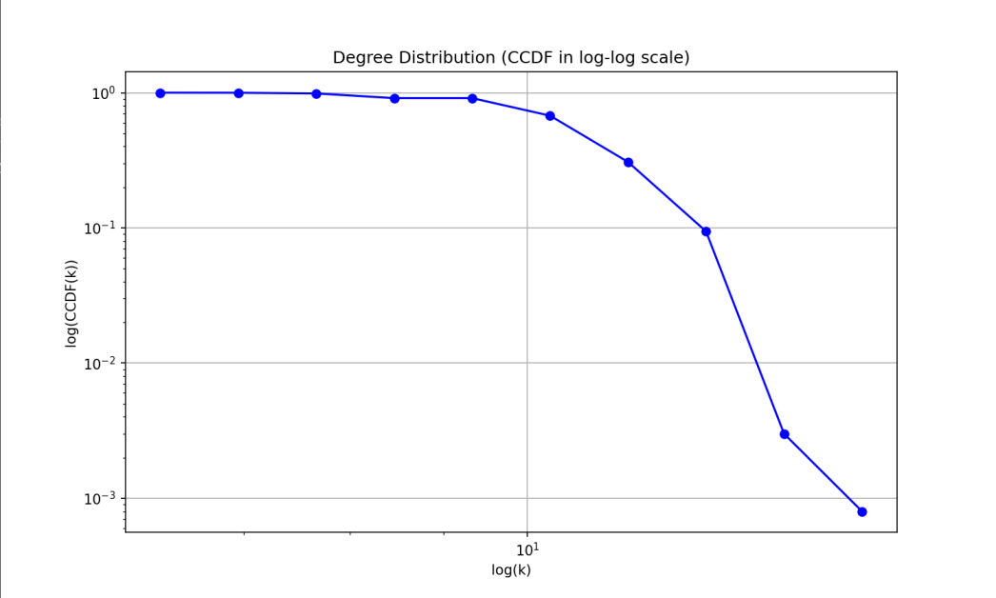

Net2

Network Statistics:

Nodes: 5000

Edges: 24873

Min Degree: 1

Max Degree: 24

Avg Degree: 9.95

Avg Clustering: 0.0021

Assortativity: -0.0057

Avg Path Length: 3.96

Diameter: 7

Top Central Nodes:

Degree:

Node 1581: 0.0048

Node 787: 0.0046

Node 52: 0.0042

Node 1990: 0.0042

Node 4917: 0.0042

Betweenness:

Node 1581: 0.0033

Node 787: 0.0026

Node 4382: 0.0025

Node 52: 0.0023

Node 2375: 0.0023

Eigenvector:

Node 1581: 0.0412

Node 3233: 0.0343

Node 787: 0.0341

Node 2375: 0.0337

Node 131: 0.0335

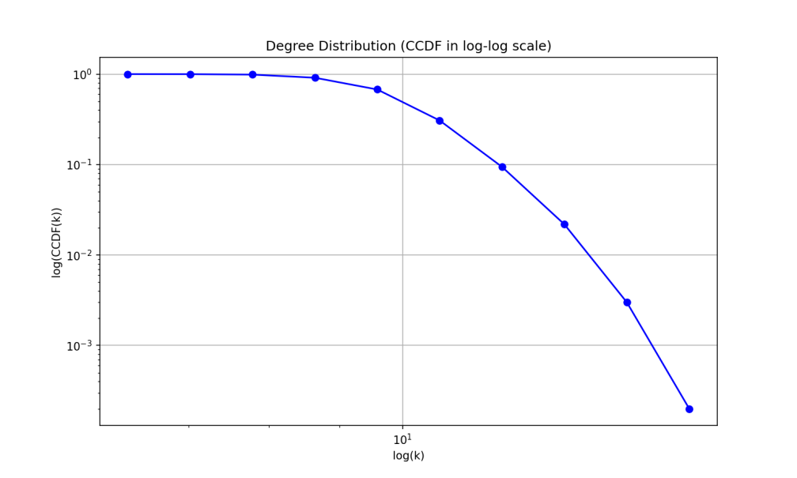

Net3

Network Statistics:

Nodes: 5000

Edges: 23508

Min Degree: 3

Max Degree: 732

Avg Degree: 9.40

Avg Clustering: 0.0862

Assortativity: -0.1339

Avg Path Length: 3.01

Diameter: 5

Top Central Nodes:

Degree:

Node 5: 0.1464

Node 7: 0.1382

Node 2: 0.1252

Node 0: 0.124

Node 6: 0.111

Betweenness:

Node 5: 0.1378

Node 7: 0.1277

Node 0: 0.1113

Node 2: 0.1093

Node 6: 0.0943

Eigenvector:

Node 5: 0.2592

Node 7: 0.2417

Node 2: 0.2254

Node 0: 0.2254

Node 3: 0.207

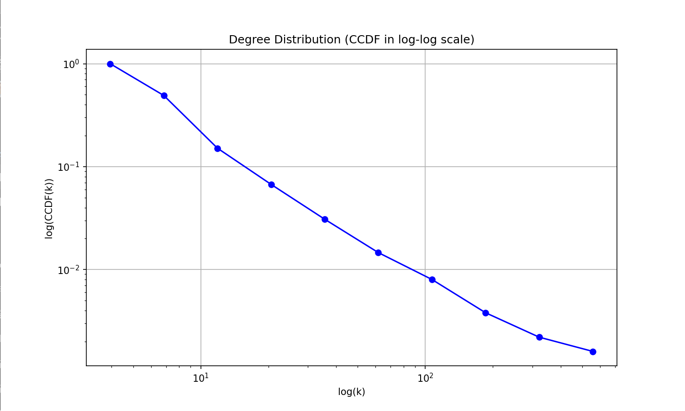

Net4 BA

Network Statistics:

Nodes: 5000

Edges: 24975

Min Degree: 5

Max Degree: 210

Avg Degree: 9.99

Avg Clustering: 0.0107 0.05-0.15

Assortativity: -0.0325

Avg Path Length: 3.49

Diameter: 5

Top Central Nodes:

Degree:

Node 6: 0.042

Node 0: 0.0412

Node 9: 0.0408

Node 10: 0.0326

Node 8: 0.0324

Betweenness:

Node 0: 0.0605

Node 6: 0.0576

Node 9: 0.0553

Node 8: 0.0391

Node 3: 0.0379

Eigenvector:

Node 6: 0.2239

Node 0: 0.2234

Node 9: 0.2062

Node 8: 0.1741

Node 3: 0.1686

